 |   Assignment Brief  Dr. Rami Al-Quran  Huda Al-Falah_22220033_40201100

Part 1:
1. Describe the process of building an application.

Step to Build an application:

- Define and understand the problem application.
To get started, check exactly what problem your application is having. Understanding user needs and gathering requirements are the first steps to doing this.

- Think of a way to solve the problem.
List all possible ways to solve the problem. Think about the different methods, strategies and techniques available. Determine which option best matches my goals.

- Present the way of solving the problem in the simple steps (Algorithm).
Breaking down the optimal solution into smaller, more achievable tasks or steps. This is accomplished by creating an algorithm or strategy that specifies the steps that must be taken to achieve goals. Focus strongly on efficiency and clarity during algorithm development stages.

- Write a code that implements the algorithm.
Convert each algorithm step into programming language code. Adherence to software development best practices. Write clean, well-organized code that makes it easy to read and understand and that will be easy to maintain and grow in the future.

- Test the code.
Checking the program (code) to ensure that it works as intended and meets all requirements without making any errors. He looked for any errors or problems that appeared during the program scanning process and addressed them.

- Document the code.
To make code more maintainable, it must be documented. Explain the purpose of each function, class and module in the code with concise and understandable comments. The inputs that the code requires as well as the actions and results that it validates are documented in the code.

2. What is your understanding of an algorithm, explain the importance of algorithms in computer programming.

Algorithms:
These are guidelines and specifications that clarify how to complete the assignment or difficulty. It is used to everyday problems and programming issues. By breaking the problem down into manageable pieces, the problem is solved, and the programmed program may be easily converted into a working program.

Explain the importance of algorithms in computer programming:
Because algorithms improve the processing, sorting, and storage of data, they provide the best answers to problems in computer programming. For this reason, algorithms are crucial. It increases the efficiency of the application in this way, making it work more quickly. Because they automate decision-making processes and provide solutions to challenges, algorithms are essential to all branches of computing and allow computers to perform difficult tasks accurately and efficiently.

3. How do you ensure that an algorithm is efficient and effective

Clear and Unambiguous:
The steps of the algorithm must be completely clear, eliminating any possibility of lack of understanding of the algorithm, ambiguity or different interpretations. When completing the application, each step should be easy to understand and unambiguous. Confusion and inconsistent use of the method can result from ambiguity and lack of knowledge about it. To ensure that everyone is reading the algorithm exactly what each step involves, it must be clear.

Well-defined inputs:
This highlights how important it is to specify the inputs the algorithm needs, including any possible types, formats, and ranges. It ensures that the algorithm can adequately handle different input scenarios. If the input is unclear, the algorithm may not work well or not handle specific input scenarios, resulting in errors.

Well-defined outputs:
These emphasize how important it is for the algorithm to define all of its outputs, including the types and formats of the results. It ensures that the results are reliably understandable and useful. Users are better able to understand outcomes and make defensible decisions when there are clear deliverables. Misunderstandings or misinterpretations may result from unclear or poorly defined deliverables.

Finite-ness:
This standard highlights that the algorithm must finish after a finite number of steps and must not run forever or become trapped in an infinite loop. It guarantees that the algorithm will finally finish and produce a result. Algorithms that never finish render themselves useless, possibly causing the system to fail or freeze.

Feasible:
This highlights the need for the method to be executable within the limits to which it can be set, ensuring that the algorithm can be implemented efficiently and within reasonable limits. Excessive resource requirements may make the algorithm unusable, leading to performance problems or even system failure.

Language independent:
The algorithm must be explained using clear logical instructions and be independent of any particular programming language. It should work with any programming language. The versatility and applicability of language-independent algorithms extends to different programming languages and settings.

4. Outline the steps involved in writing code for a program.

Gathering requirements:
This step involves understanding what the program needs to do and determining the requirements and limitations of the application. Ensuring that the application meets its goals in the correct way.

design:
Solution design includes planning the structure of the program (code) and its functions. This involves creating an outline of how the code will work. The design phase helps organize the development process and ensures all components work together smoothly.

development:
This step involves writing the actual code for the program. It involves implementing features and functions as defined in the design phase, using an appropriate programming language.

Tests:
Testing involves verifying that the software (code) works correctly and meets specified requirements. The goal is to identify and fix any errors or problems.

maintenance:
Maintenance includes updating and improving the software. This includes fixing any bugs that are discovered (code), and adding new features. Maintenance is an ongoing process that helps keep the software relevant and useful.

5. Describe the process of compiling code into machine-readable instructions

Writing Java source code results in .java files, which the Java compiler (javac) then translates into byte code. This bytecode, which is maintained in .class files, is platform independent. In addition, the compiler separates the code into distinct symbols, such as operators and keywords, by lexical analysis. While semantic analysis makes sure that type checking and grammar adherence are maintained, syntax analysis verifies that the code follows Java syntactic rules. It is the process of translating the parse tree into byte code, which can be improved for efficiency by generating intermediate code. After downloading the .class files, the JVM checks the bytecode for security. Native machine code may be generated at runtime from bytecode via just-in-time compilation. Finally, the JVM executes the native code, managing memory and resources as needed. The entire process involves multiple stages, from writing code to implementing and executing it efficiently.

6. Provide an example of an algorithm and clearly explain it. Then, implement the algorithm using a programming language. You will include this algorithm in the paradigms below.

Algorithm Bubble Sort:
Bubble Sort is an algorithm that operates in a simple sorting method that exchanges items if they are out of order by repeatedly moving over the list to be sorted and comparing any adjacent items. The list is repeated repeatedly until it is sorted. It can be used in ascending and descending order of array.

Benefits of bubble sorting:
Bubble type is easy to understand and use. There is no need for additional memory space as it has enough space. Since the sorting process is stable, elements with the same cardinality in the sorted output maintain their relative order.

How the algorithm for bubble sorting operates:
Depending on the system we desire, the algorithm compares nearby elements (big or tiny) as it traverses from the left, placing the highest element on the right. In this manner, the greatest (or smallest) piece is originally shifted to the far right. Once the data is sorted, this procedure keeps going until it finds the next largest size (or the smallest size) and places it.

Steps in a bubble sort:
1. Commence at the top of the list.
2. Examine the initial pair of things. Swap them if you want the order to be ascending and the first is greater than the second.
3. Go on to the next set of objects, compare them once more, and make any necessary swaps. Till the conclusion of the list, keep going through this process.
4. The next biggest item will show up in the right place after each list scroll.
5. Continue this process over the whole list, omitting items that have just been sorted, until no more rearranging is required.

I used the bubble sort algorithm in an application I have. It helps me in ordering the size of the wool in descending order. This is the application code that was used in the bubble sort algorithm:
1.
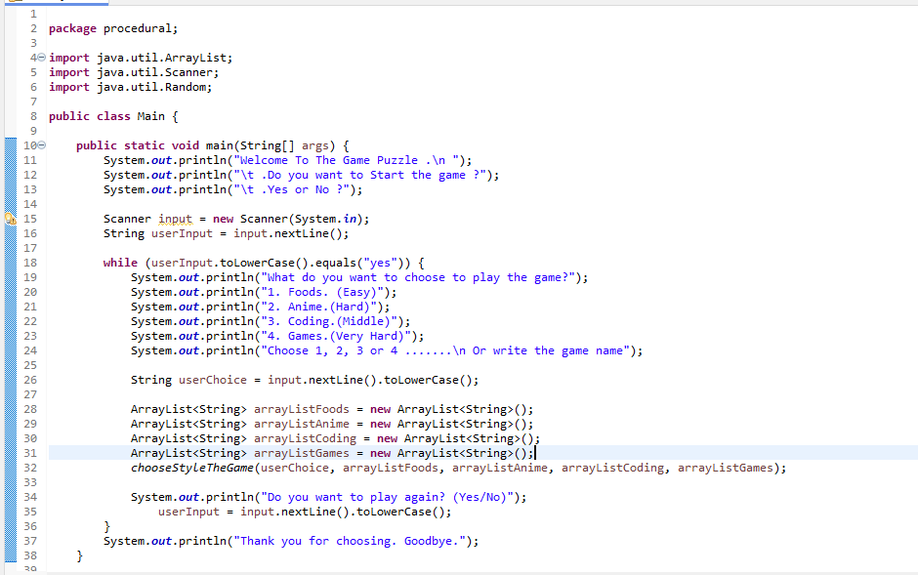
2.
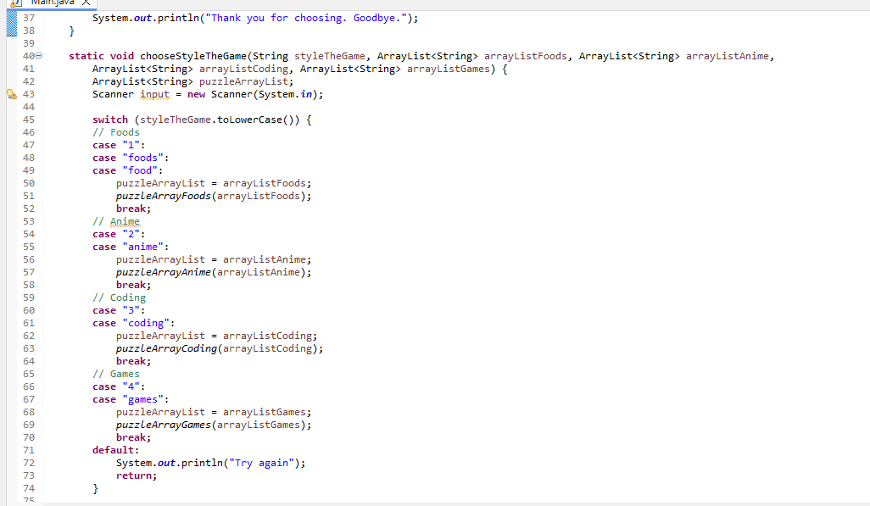

3.
Here at line 76, we have called function a bubble sort algorithm that sorts list arrays in descending order.

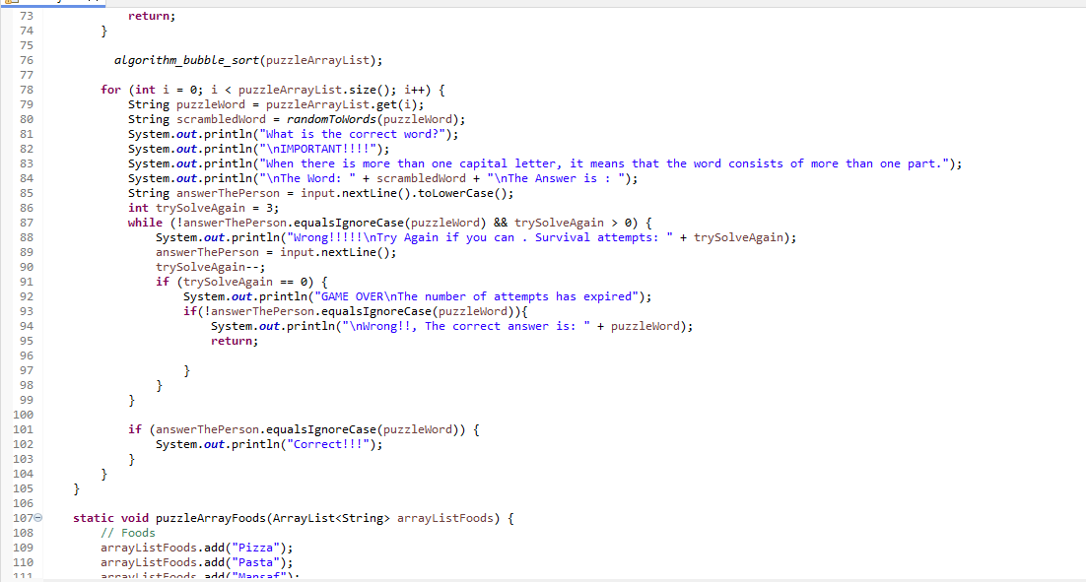
4.

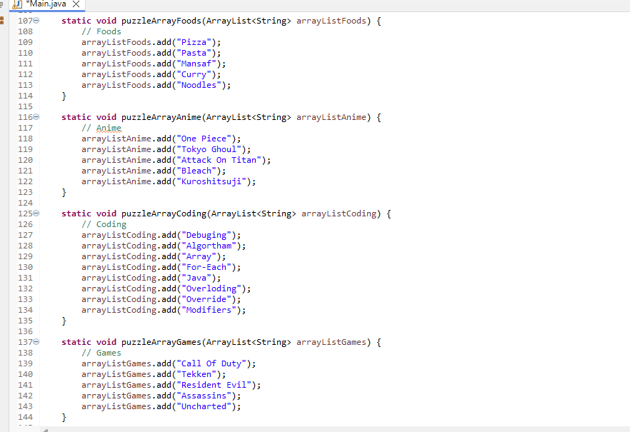

5.
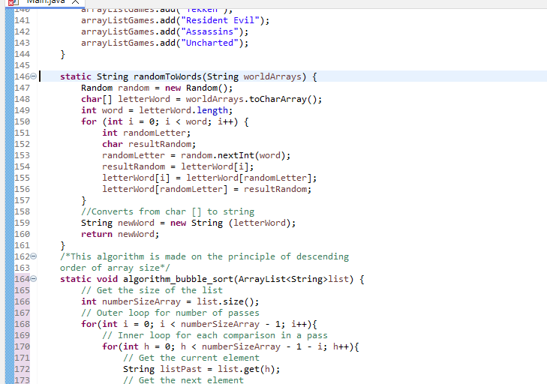
6.
In line 164, a function (algorithm_bubble_sort) is used that implements a bubble sort algorithm that runs in descending order of the size of list arrays.
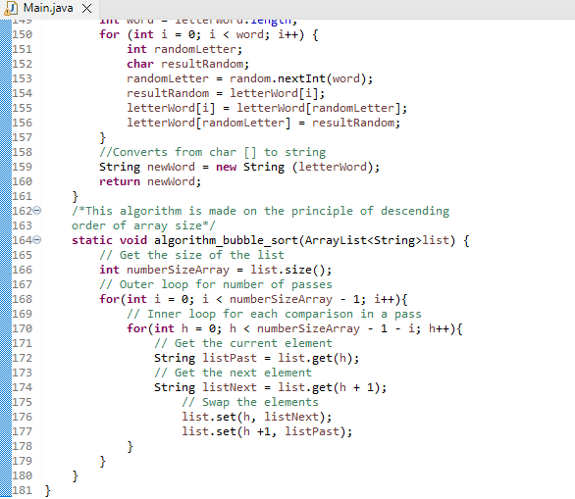

Definition and explanation of the function of the bubble sort algorithm:
- An ArrayList of string type is arrayed in order to use the bubble sort function. It returns null, or no value at all.

- The size() method is used to find the size of the list. For later use, this value is kept in a variable.
Outer ring:

- The range of the outer loop is 0 to the list size minus one. The amount of iterations through the list is managed by this loop. The next larger item is moved into its correct position with each pass.
Inner ring:

- The inner loop inside the outer loop has a range from 0 to the size of the list minus one, minus the pass index (i) that is currently in use. Adjacent elements in the list are compared through this loop.

- Elements are compared and swapped to each pair of adjacent elements in the inner loop. Toggled if the current element is larger than the subsequent element. Temporary variables are used to store the values of elements while they are swapped.

- Finally, iteration and completion are done in terms of sorting all the elements in ascending order by repeating the process until the outer loop ends. The largest unsorted element is moved to its correct location at the beginning of the list with each iteration of the outer loop.

Part 2:
1. Define the procedural programming paradigm and its key characteristics.

Procedural programming paradigm:
Program code is separated into distinct pieces of code called procedures, each of which performs a specific task, according to the procedural programming model. Procedures, often known as functions or subroutines, are sets of computational steps that the programmer specifies to perform in a specific order.
A paradigm is not a real thing (like a programming language), but rather a method of doing something (like programming). A "method" or style of programming is called a programming model. Certain programming languages have an advantage when writing in certain paradigms over others.

Key Characteristics:

Passing the parameter:
Sending data values to functions as input when they are called is known as parameter passing. The function receives these values, also referred to as parameters, and processes them. Functions can work on different data each time they are called thanks to parameters, which increases the flexibility and reusability of the code.

The quality of modularity:
Splitting a program into more manageable chunks known as functions or procedures is a technique known as modularity. Every process can be reused in other sections of the program and is created to carry out a specific purpose. Code that is written using modular programming is easier to read, maintain, and manage.

Predefined Functions:
Programming languages come with built-in functions called predefined functions, which can also be imported from libraries. Programmers can complete jobs without starting from scratch with code thanks to these functions. They provide frequently used functionalities, which improves code efficiency and simplicity.

Top-Down Method:
Programs are designed and written using the top-down method, which divides them into smaller, easier-to-manage components. With this method, a primary module is first created, and it is then progressively divided into smaller sub-modules, each of which is in charge of a certain capability. The organization, understandability, and ease of debugging of code are enhanced by the top-down method.

Local and International Variables:
Local variables can only be accessed inside the confines of the procedure or function in which they are defined. They are transient entities that vanish as soon as the process is carried out. Conversely, global variables are available to all procedures and functions within the application and can be utilized by them. They come in use when exchanging data between several program components.

2. Explain the concept of object-oriented programming (OOP) paradigm and its fundamental principles.

Object-Oriented-Programming:
It is a model that is applied by classifying objects that serve as representations for actual entities in the real world. These objects' corresponding methods are used to bind them together. It is frequently employed to divide a large activity or issue into manageable chunks. The concept of objects that can hold both code and data is the foundation of object-oriented programming, or OOP. While data can be represented as fields (attributes or properties), code might take the form of procedures (methods). Computer programs are constructed from interrelated pieces using object-oriented programming, or OOP. Most popular programming languages support imperative, procedural, and object-oriented programming to varying degrees and are multi-paradigm languages.

Fundamental principles:
- Object and Class:
The classes are a collection of objects that share common behavior properties and common attribute properties. It is a specific blueprint or prototype from which objects are created.
Objects represent real-world entities and are the basic basis of object-oriented programming. Objects are instances of classes designed to use their methods and attributes. Several objects are created by a normal Java application, and they interact by calling methods. An object's identity is what gives it a distinct name and permits it to interact with other objects. the state that the object's properties represent. It also reflects the properties of the behavior that the object's methods represent. It also reflects the response of an organism to other things.

- Encapsulation:
Among the most potent and essential OOP ideas Integrating data and functions into a single unit (class) to protect them from outside interference and misuse.Direct access to the data (class attributes) is prohibited.The sole method to retrieve these data ought to be through functions.These are the Java member functions, sometimes known as methods. In essence it forms a shield that prevents access to the code or data from outside the shield.

- Inheritance:
Inheritance is a concept where one classes properties and methods can be inherited by another, allowing code reuse and establishing relationship between classes. It is a method where a class can be derived from another, creating a natural hirarchical organization of classes, enabling code reuse and supporting method overriding. The subclass inherits attributes and method from the superclass.

- Polymorphism:
Polymorphism is a way to redefine methods in derived classes, allowing objects from different classes to be treated as objects of a superclass or interface. It means you can use a single method to work with different types of objects, depending on the arguments passed to it. This offers great flexibility and reusability in your code, making it easier to manage and extend:

- Methods and Attributes:
The attributes: Its a variables connected to objects are called attributes. They serve as an object's representing its state. Every object may possess a unique collection of characteristics. An object's attributes specify its qualities or traits.
The methods: The methods are functions specified inside a class and linked to objects derived from that class in object-oriented programming. Methods provide an object's behavior definition, action capabilities, and internal data manipulation capabilities. (6)

3. Describe the event-driven programming paradigm and how it differs from procedural and objectoriented paradigms.

Event-Driven:
Event-driven programming is a programming paradigm in which program execution (Flow) is determined by user events. They are compatible with all programming languages. Event-driven programming can be done in any object-oriented or visual programming language. Graphical User Interface (GUI) deployments are among the most well-known uses of this paradigm.

Object-Oriented programming:
Rather than structuring software design around functions and logic, object-oriented programming (OOP) organizes it around data, or objects. An object is a specific instance of a class that has methods (functions) and data (attributes). Encapsulation, inheritance, and polymorphism are highlighted by OOP. Classes can inherit characteristics from other classes through inheritance, methods can do different actions depending on the object they are operating on thanks to polymorphism, and encapsulation protects data from outside influence. For complicated applications that profit from code reuse and modularity, this paradigm works well.

Procedural Programming:
Procedural programming is to complete tasks by following a set of stages or procedures. It divides the software into functions or procedures, each of which carries out a particular task. Unless loops or conditionals are used, the program executes in a top-down, linear fashion. Linear flow, reusable functions, and variable-based global state management are important features. For jobs having a distinct, linear growth, such as basic data processing applications, this paradigm works well.

The difference between OOP, Event-Driven and Procedural:

Control Flow:
- Event-Driven Programming an the event loop and outside event influence the direction of control flow.
- Object-Oriented Programming it’s interactions between objects and their method are what drive control flow.
- Procedural programming it’s the order in which function calls are made that determines the predetermined, linear control flow.

Focus to:
- Event-Driven Programming is perfect for interective applications since it’s event-driven and focuse on responding to event.
- Object-oriented programming emphasizes data encapsulation and modularity while focusing on simulating real-world entities as object.
- Procedural programming it’s the best suited for activitie that follow a straight line of progression, because it focuse on a set of step to complete the task..

State Administration:
- Event-driven programming are changes to a state are handled by event handler in response to events.
- Object-Oriented Programming it’s state is managed through object attributes with method providing controlled access and modification.
- Procedural programming uses the local and global variables to manage state inside procedure.

4. Provide examples of code that primarily demonstrate the three paradigms mentioned above, showcasing their core features.
The properties and traits of each programming paradigm will be compared in this section with respect to the examples given for each paradigm.

Procedural Paradigm:

- Dividing the code into functions, which are smaller sections this is shown in the procedural example, which defines distinct functions for each task, including puzzleArrayFoods, puzzleArrayAnime, and chooseStyleTheGame.
- using a top-down methodology the execution is controlled by the main method, which accepts input from the user and branches out to specified functions in response to their selections.
- Doesn't firmly enforce data concealing Throughout the routines, all data is available without the need for robust encapsulation techniques.
- Implementing new features is difficult because the program flow is strictly regulated, adding new functionality may need changing the current code.
- Absence of access modifiers makes the code less safe as any location inside the program can access and change any data.
- Data hiding and lack of inheritance because procedural programming does not permit inheritance, it is challenging to add new features without changing the old code.
- Put the focus on logic and procedure rather than simulating actual objects, the procedural example concentrates on the steps that must be taken.
- Functions are more important than data the emphasis is on defining and executing functions rather than organizing data into objects.
- For medium-sized shows, use in general, less complicated and simpler applications are a good fit for procedural programming.
- Restricted capacity to reuse writing modular functions is necessary for reusability, but overall, object-oriented programming offers more flexibility.

Event-Driven Paradigm:
- User actions inferred from the task but not explicitly stated, the event-driven example would handle user in such as ActionListener, MouseListener, and KeyAdapter in response to user activities.
- Applications using a graphical user interface for graphical user interface (GUI) applications, where user interactions control the application st teractions by using event listeners to handle keystrokes and button clicks.
- Asynchronous flow more dynamic and responsive applications are possible because the program flow is dictated by events rather than a preset order of operations.
- Employs handlers and listeners for events: Certain code blocks are executed when certain events occur by components ate, event-driven programming is especially well-suited.
- Flexibility and interactivity: Event-driven apps are very interactive and user-friendly because they can quickly adjust to changes in input from the user.

Object-Oriented Programming:
- Breaking the code into objects, or smaller units of representation: This is illustrated in the object-oriented example by defining classes such as ChooseStyleTheGame, WordRandom, and ArrayListPazzly.
- Follows a bottom-up approach object methods and interactions drive the program flow; objects and their interactions are constructed first.
- Uses modifiers of access to improve security and encapsulation, private, public, and protected modifiers are used to control access to object properties and methods.
- Add new objects and methods with ease polymorphism and inheritance make it easier to introduce new features without changing the old code.
- Increased protection encapsulation and access modifiers guard against unauthorized access and alteration of data.
- Data hiding and inheritance are supported by object-oriented programming, which makes code more modular and manageable.
- Represents real-world items and relationship the example mimics real-world entities by modeling user interactions and game logic as objects.
- Data encapsulation is the process by which functions and data are combined into objects, giving the data equal weight with the functions, if not greater.
- Used to large and intricate program complex, scalable applications are ideally suited for object-oriented programming.
- Increased reusability polymorphism and inheritance allow for a large amount of code reuse, which speeds up the development process.

5. Compare and contrast procedural, object-oriented, and event-driven paradigms in terms of their approach to programming (Support your claims using screenshots of your code):
Describe how the source codes utilize each paradigm.Reflect on how the chosen programming paradigms align with the overall goals and requirements of your application.
The procedural coding:
This code organize the programs procedural code as a series of instructions in the main class. It divides the program into function, such as main(), chooseStyleTheGame(), and different puzzle array methods, each of which are responsible for specific tasks. These include specific functions, and the programs flow is controlled through method calls and loops. Data structures (ArrayLists) are used to manage game data. Alignment with goal procedural programming simplifies the structure of the game, focusing on step-by-step execution. It’s suitable for straeightforward applcations with clearly defined steps such as this game, promoting code readability and simplicity. Procedural programming simplifie code structure and execution flow.
How the code works has been explained in the pictures:

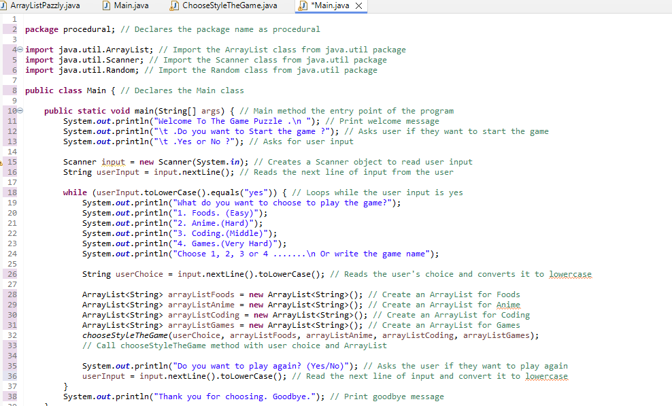

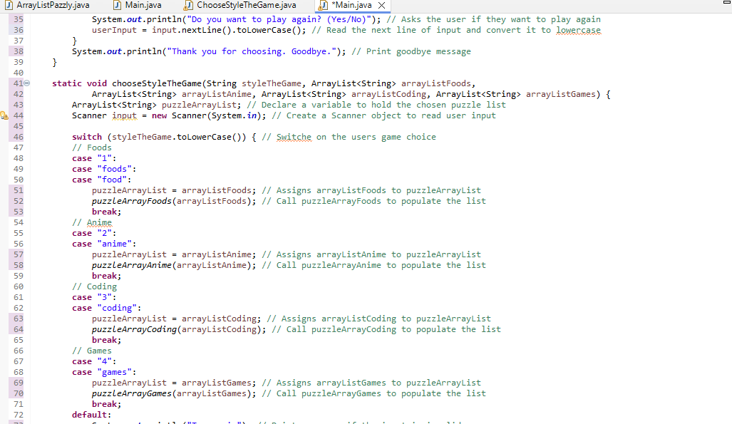

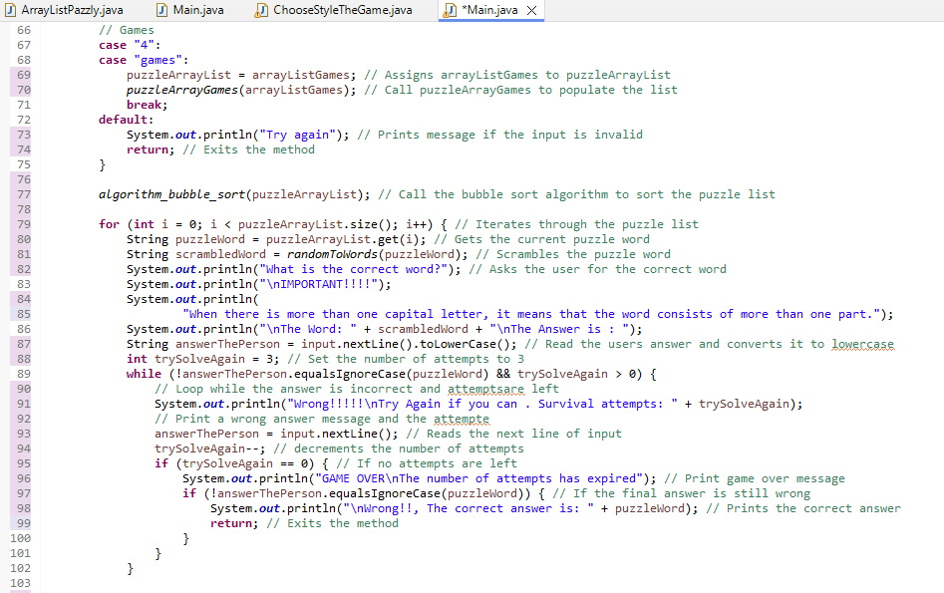

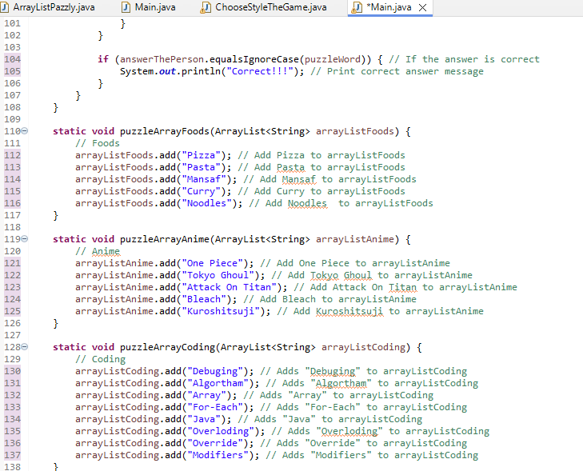

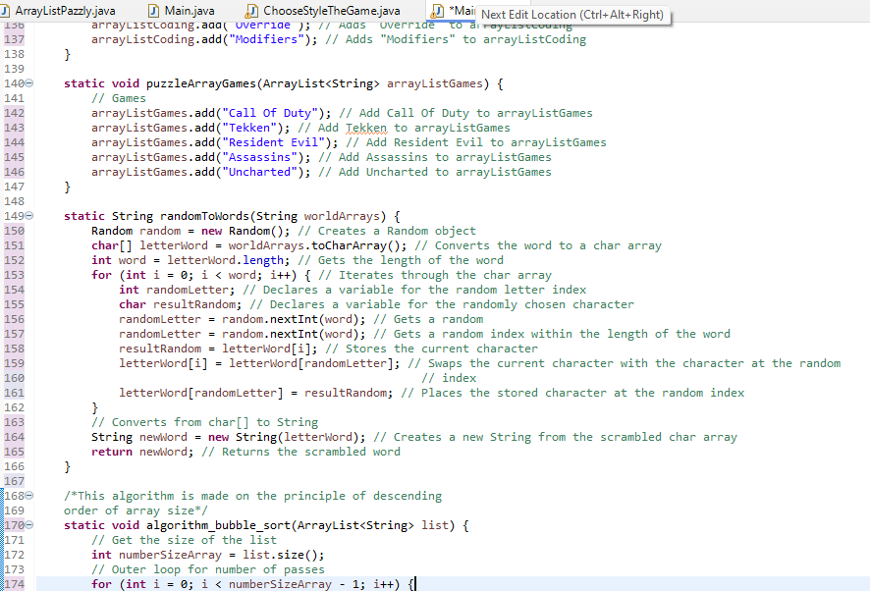
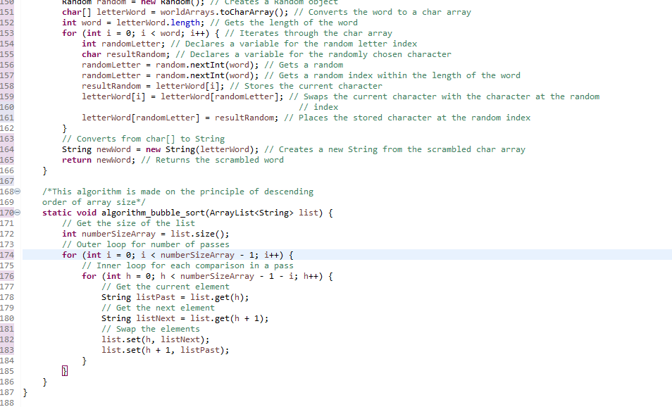

The object_oriented_programming coding:
This code works to provide object-oriented code with classes
(ArrayListPazzly, WordRandom, and ChooseStyleTheGame). It uses encapsulation, inheritance, and polymorphism. Each class represents a real entity or a conceptual entity, (game classes or game logic). Methods and attributes are encapsulated within classe, enhancing modularity and reusability.OOP improve code organization and maintainbility, and improve code organization, modularity, and extensibility.
How the code works has been explained in the pictures:

Class ArrayListPazzly:

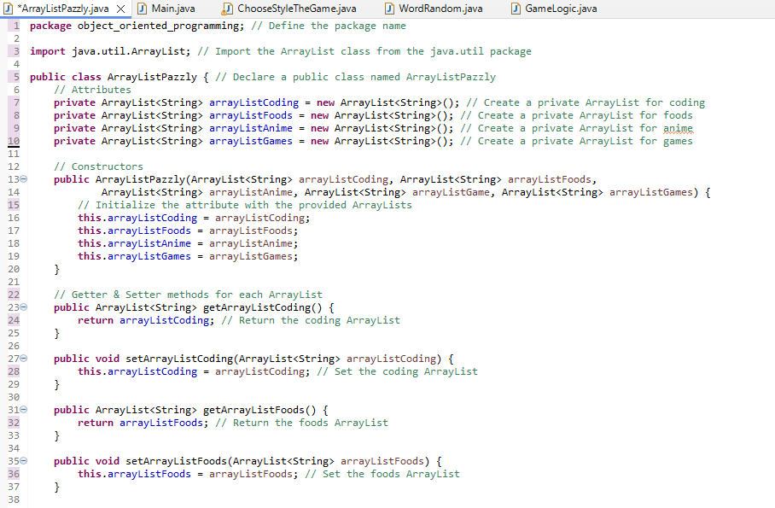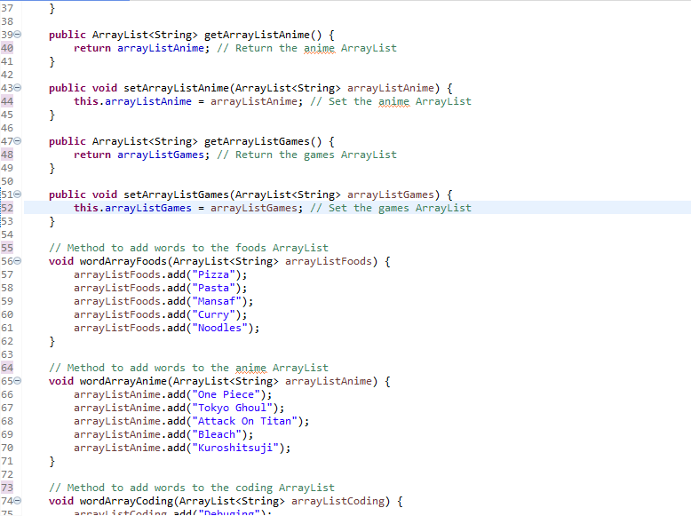

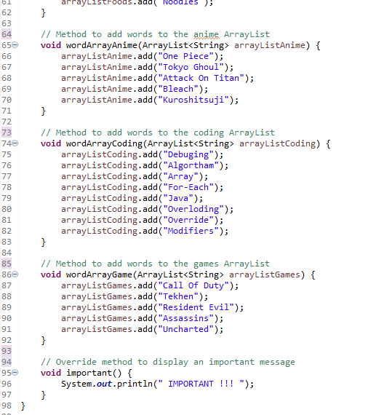

Class WordRandom:
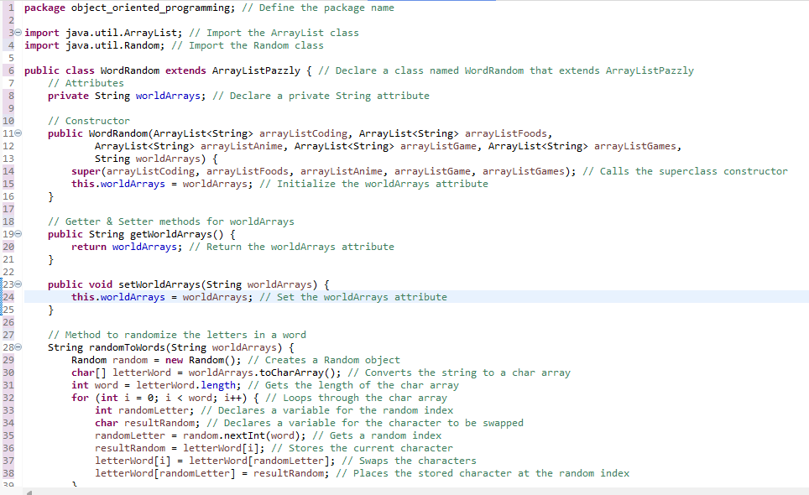

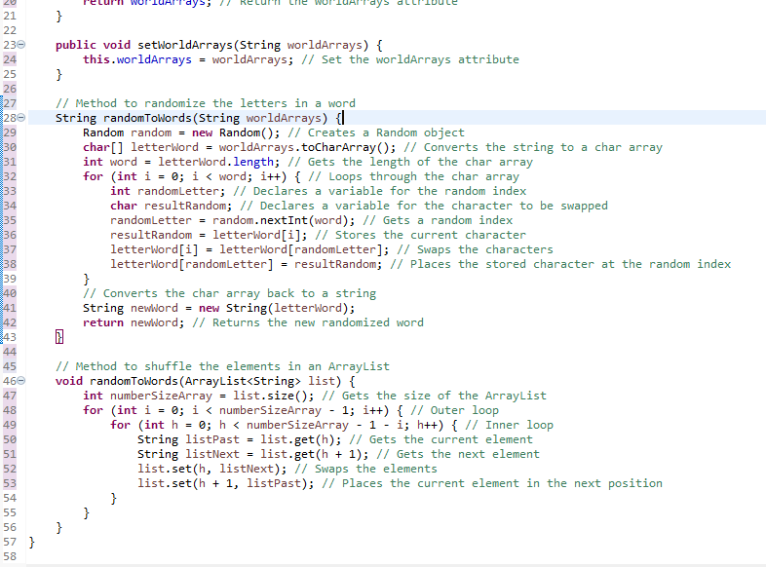
Class chooseStyleTheGame:
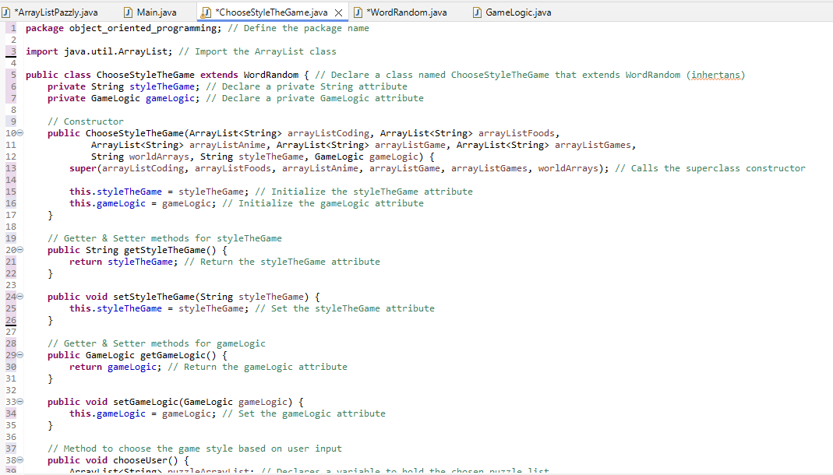

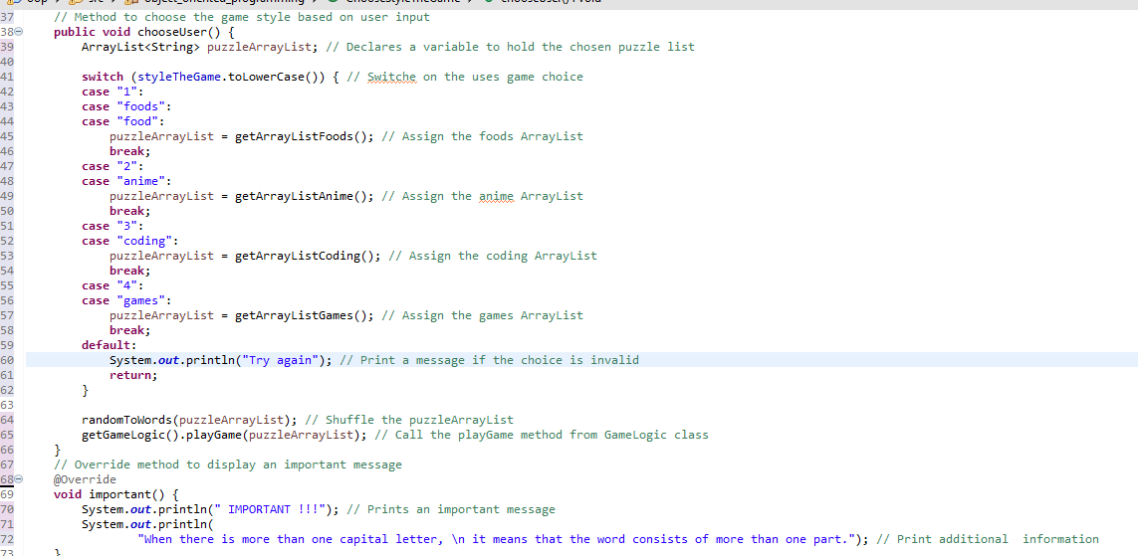

Class GameLogic:
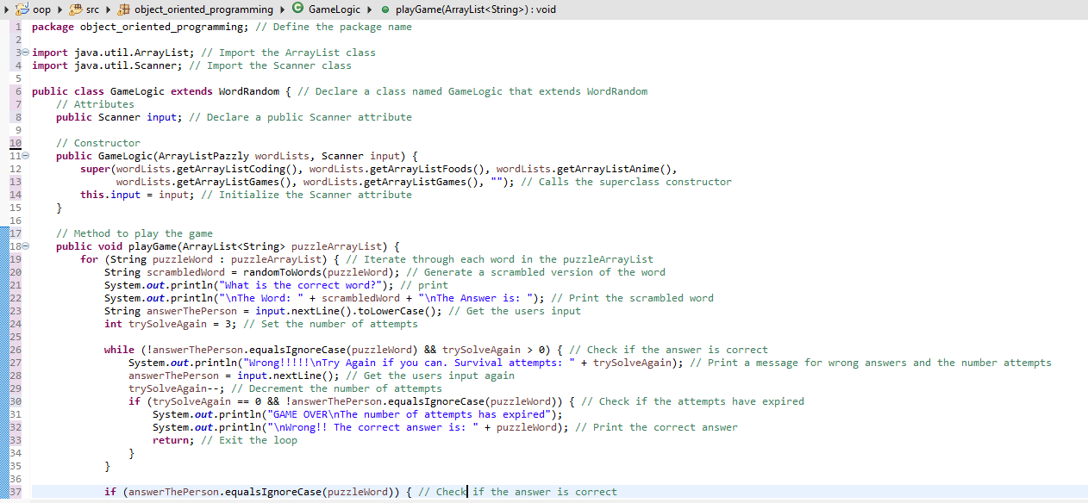
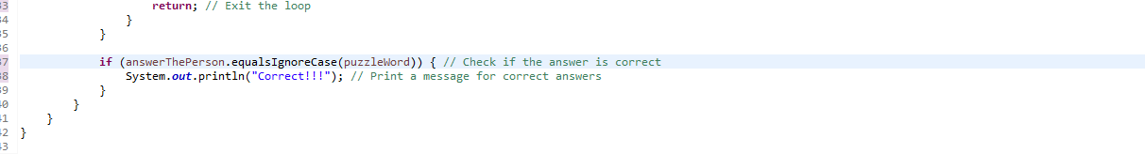

Class Main:

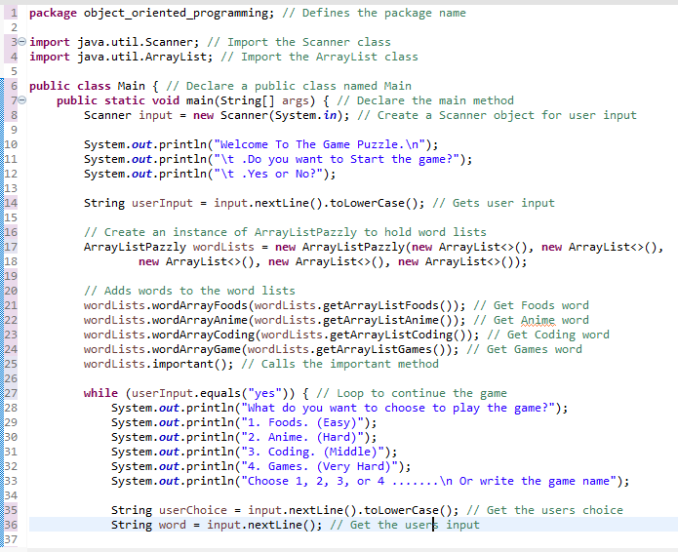
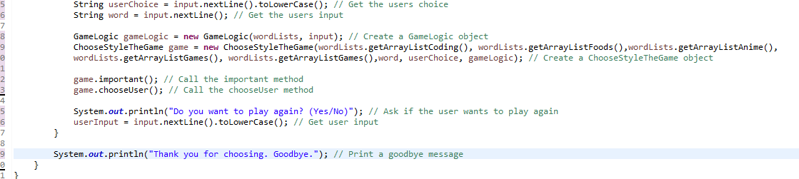

Event Drivan:
In the code, event-driven code uses components Swing, CardLayout, JLabel, JTextField, JComboBox<String>, JFrame, JPanel) and event listeners (ActionListener, MouseListener, KeyListener, MouseMotion Listener). User interactions trigger events, such as button clicks or keystrokes. Components respond to user actions asynchronously through event listeners, enabling dynamic and interactive user interfaces. The program flow is event driven and not linear. Event-driven programming is suited to interactive applications, where user actions drive program behavior. It enhances user engagement and responsiveness by allowing instant feedback on user input.
How the code works has been explained in the pictures:
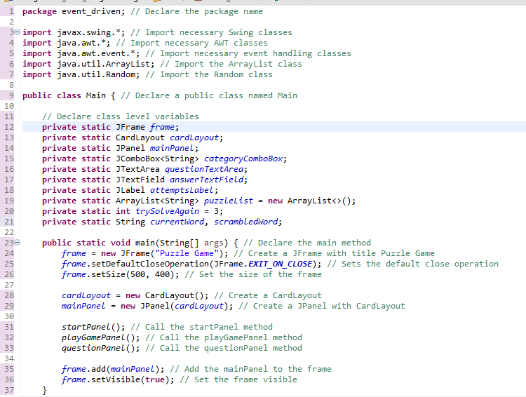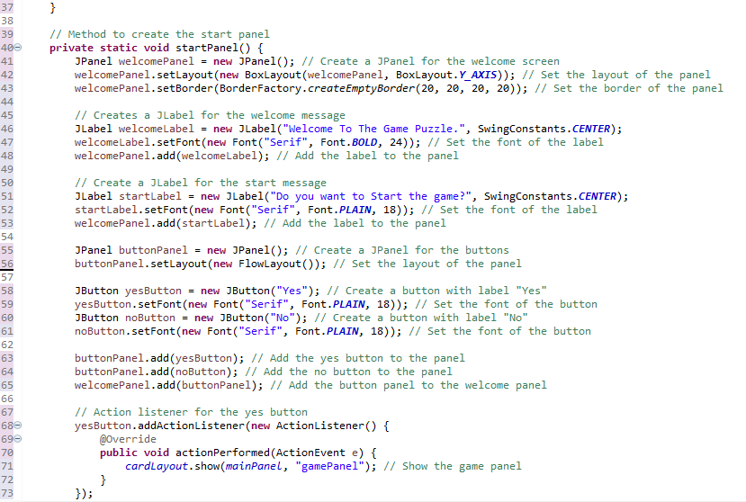

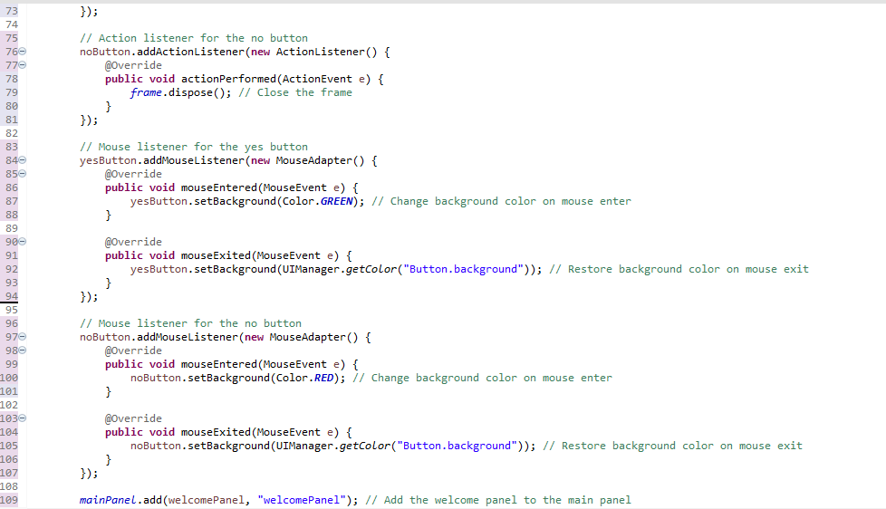

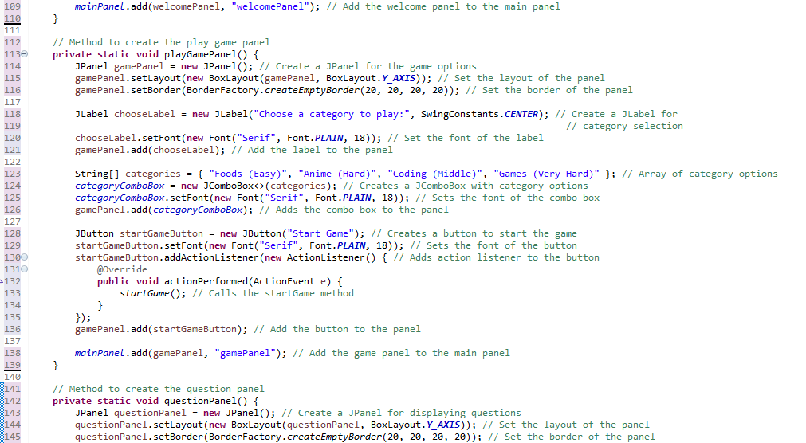

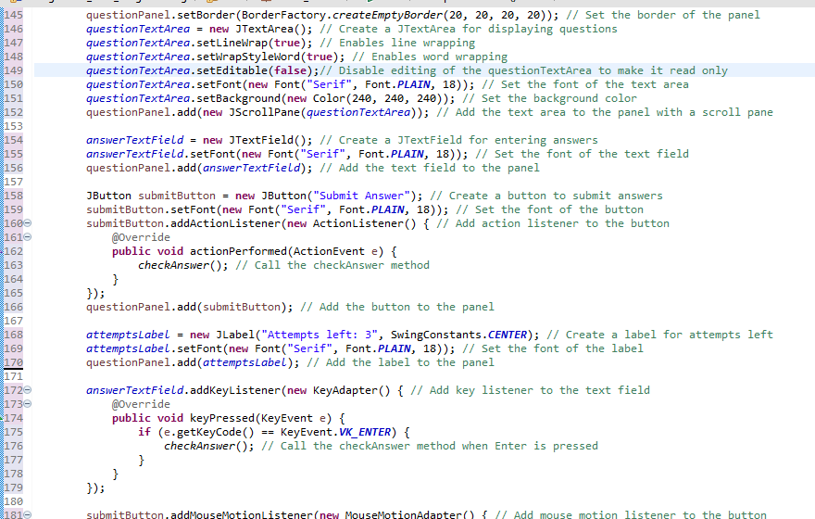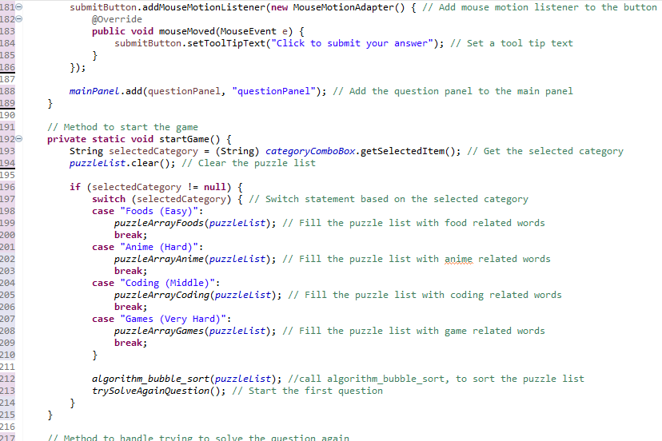

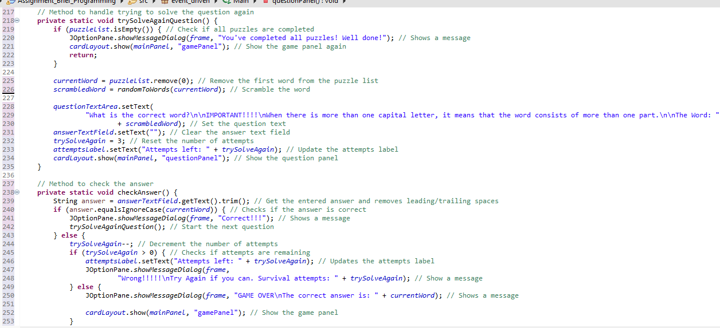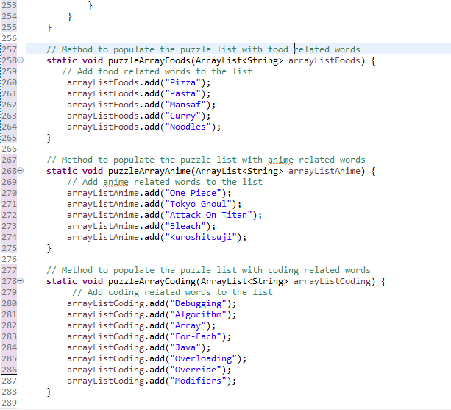

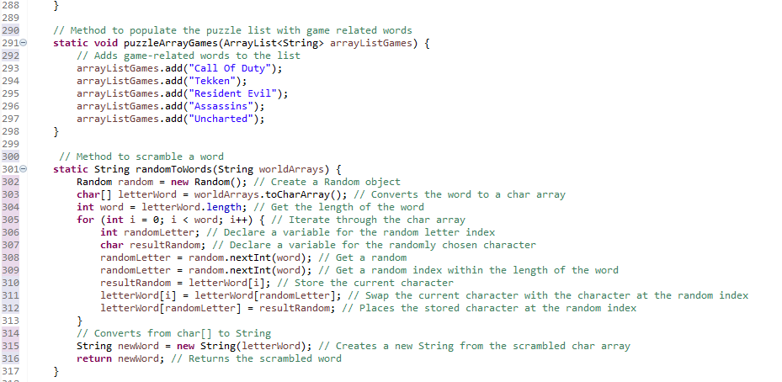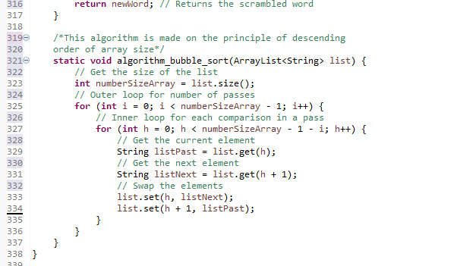

6. Provide a complete scenario where a combination of these paradigms might be beneficial in software development. Include the previously written algorithm in your program.
1. Procedural:
In my co, I created a main method entry point. The main method acts as the entry point for the program, just like the starting point for a recipe. It greets the user, asks them if they want to start the game, and reads their input. I created an iteration structure where my code uses a time loop to keep the game running for as long as the user wants to play. This is like following the steps of a recipe continuously until you decide to stop (no) or finish playing. Create functions like ChooseStyleTheGame, puzzleArrayFoods, puzzleArrayAnime, puzzleArrayCoding, and puzzleArrayGames that break down different tasks into smaller, manageable parts. I worked on how the switch statement is used to handle different game modes chosen by the user. It's like choosing which game to play. The code uses loops and conditions to handle user input, validate choices, and provide feedback. He made sure he entered the correct word. I used the same algorithm that is found in the first part, where the algorithm_bubble_sort function sorts the lists of puzzles, and changes the positions of the array size.

2. Object-Oriented Programming:
In the code structure I have used five classes (Main, WordRandom, ChooseStyleTheGame, GameLogic, and ArrayListPazzly) to represent different entities and functions within the program. Each class contains related attributes and behaviors, which promotes code reusability and maintainability. Inheritance is used, for example, WordRandom expands ArrayListPazzly, and this represents a genetic relationship between them where the parent is the class of the array and the child is Random. I've worked on polymorphism being demonstrated through method overriding, where subclasses provide their implementation for inherited methods. Each class encapsulates its own attributes and behaviors, limiting access to internal details and promoting information hiding. Inheritance is used to create a class hierarchy, allowing code reuse and specialization. Method overriding allows subclasses to provide their implementation for inherited methods, allowing polymorphism at runtime. The ChooseStyleTheGame class contains a GameLogic object, which demonstrates syntax, where one class contains a reference to another class. My code also contains my own algorithm, which I mentioned in the first part in the WordRandom class.

3. Event Driven:
Our event-driven approach leverages Swing components to create a graphical user interface (GUI) where users can interact with the software visually. Here's how your code implements this:
In my event code, the program simulates the game by creating a JFrame. I have used several swing components, which are (JFrame, JPanel, JButton, JLabel, JComboBox , and JTextArea) to create . These components allow interactive elements such as button, text fields, and drop-down lists. These tools are greatly enhance my game building. By implementing interfaces such as (ActionListener, MouseListener, KeyAdapter, and MouseMotionAdapter), my game program can respond to user actions such as button clicks, mouse movements, and keystrokes. Clicking a button triggers an event that performs a specific action. Users interact with the game program by clicking buttons, entering text into text fields, and selecting options from drop-down menus. The program provides feedback and prompts user input through labels, text areas, and dialog boxes. The flow of the program is controlled by user interactions and events. When the user chooses to start the game or submit an answer, the program responds accordingly by displaying different panels or messages. Feedback to the user, such as correct or incorrect answers, is provided through dialog boxes created using JOptionPane. This ensures that users are informed of the consequences of their actions.

7. How do you ensure that your code is well-documented and readable by others?

Ensuring that the private code in my application is well documented and readable by others involves several basic practices.

1. Adopting a coding standard is very important. Where it is considered a set of instrustions that defines how code is written and formatted, ensuring consistency across the code base. This is consistency reduces the risk of error improves the reliability of the code and make it's easier for other developer to understand, maintain, and see how it's work. Well written code is not only easier to read but also easier to maintain and modify, which can save a lot of time and effort in the long run. Additionally, when everyone on a team follows the same coding standard, it facilitates better teamwork and prevents misunderstandings and conflicts.

2. Writing automated tests is another essential practice. Automated tests help catch errors early and ensure that code changes do not break existing functionaliety. This provides confidence when making changes and help maintain the overall high quality of the code. Automated tests can be run quickly and efficiently, making it easier to quickly detect error and verify that the code is working as we want. By reducing the need for manual testing, automated test also free up time and resources for other tasks. When writing tests, it is important to cover all relevant scenarios and edge cases to ensure thorough testing and early bug detection.

3. Code reviews are an important part of the process because; in the code review, one or more developer review code writen by another developer and provide comment and suggestions for improvement. Or the code is reviewed by the same person, who can discover mistake and loophole that were present in his code. This practice detects error, enhances code readabilty and ensures that code meets standard and best practices.

4. Placing comments on each line or group of lines in the code help explain what the code does. This make the code more readable and maintanable, which helps future developers and myself understand its purpose and functionality. Clear, concise comments that explain why you should do something are most effective.

8. Explain the importance of testing code before execution.

What is code testing?
Code testing involves running each line of code using controlled inputs, checking if it performs the expected output and the code runs correctly. The main goal is to identify errors. Testing ensures that it meets these expectations.

Testing code before executing identifies bugs and bugs in the code if they exist, ensuring that they can be fixed before the program is executed. This reduces the chances of errors occurring in the code. Finding errors and fixing them early speeds up its implementation and reduces the time and effort that will occur while the code is not tested and errors occur in it. The test also works to protect sensitive data if there is a weakness in it.
‍

Part 3:
1. Describe the steps you take to create a new project in your preferred IDE. How do you organize project files and directories within the IDE?
The steps that helped me create a new project in the integrated development environment were in eclpise, which also helped me organize files, which are:

1. I worked on creating a new java project (this helps me organize the files in a project I have and not get mixed up with other projects)
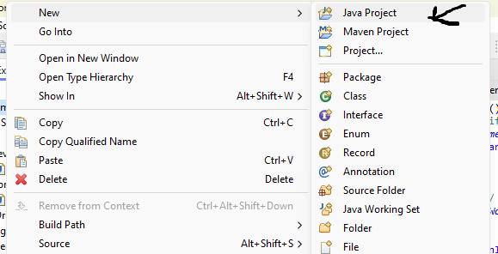

2. I worked on naming my project after the project name that helps understand and identify my project
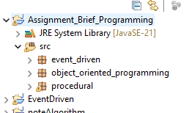

3. I created special packages for event-driven, OOP, and Procedural, which contributed to organizing each project and not mixing each class with each other.
This is done through src-----> new ---> package

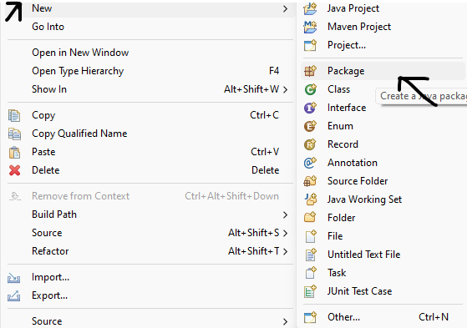

4. I worked on creating and arranging a class according to its work.
This is done through package ----> new ------> calss
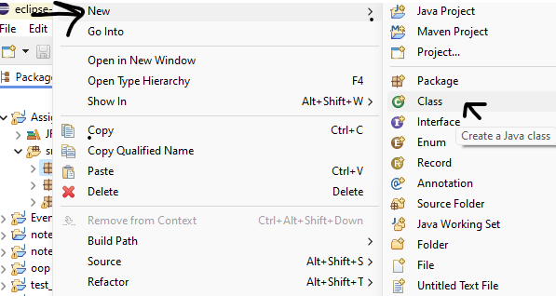

2. What features or tools provided by IDEs do you find most beneficial for your development workflow?

IDE (Integrated Development Environment) is an application that helped me improve the code, especially in my application, by providing me with many features and benefits as well as tools, and the most important tools that helped me in this are:

- Syntax highlighting made the code easier to read by assisting me in identifying any syntax mistakes.

- Programmers may quickly trace changes made to the code with version control integration. Additionally, if necessary, work with other programmers to roll back the code to its earlier version.

- Refactoring by enabling them to make significant modifications to the code structure without compromising the operation of the software, this feature allowed me to make code maintenance easier.

- Auto-completion was helpful to me because it cut down on the amount of work required to type the code. It also lessens the possibility of syntactic mistakes.

- Debugging by enabling me to go through my code, examine the variables in the code, and analyze call stacks, this functionality assisted me in finding and fixing faults and issues.
The IDE helped me provide tools and an environment during the application process, and this contributed to its success and implementation. It gave me access to the tools I needed in my code. It contributed to saving my time and effort.

3. Describe any specific IDE debugging features you find helpful.
One of the tools that helped me correct errors that I encountered while implementing the application is breakpoint and dubggen, which are:
- A breakpoint is a signal at a specific place in the code that directs the debugger to pause the program's execution for a while.
- The debug perspective offers additional views that can be used to troubleshoot an application like Breakpoints, Variables, Debug, Console etc. When a Java program is started in the debug mode, users are prompted to switch to the debug perspective.
This helped me solve many problems that occurred while writing the code and testing before implementation. It helped me track the process of how the code is implemented, see where the code problem exists, and work on solving it.

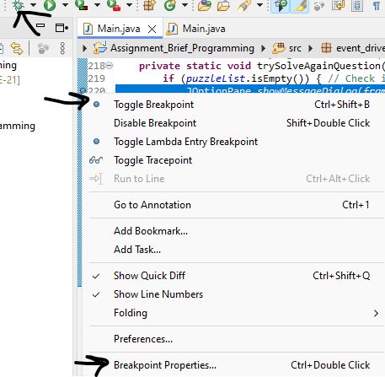

Integrated Development Environment IDE:
4. Compare the overall development experience, including speed, efficiency, and ease of use, between using an IDE and not using one.
With many tools and features that increase efficiency and productivity, integrated development environments (IDEs) greatly improve the application development process.

Enhanced Efficiency and Productivity: Code Highlighting: This feature helps to visually distinguish between distinct elements of the code, such as variables, keywords, and syntax errors, making it easier to track and discover problems or defects.

Auto-Completion: This feature reduces the amount of typing required and minimizes syntax errors while speeding up development by proposing completions for partially written sentences.
Improved Debugging The capabilities:

Breakpoints: Enable developers to stop a program's execution at predetermined intervals, which makes it simpler to examine the application's status and spot problems.
Debugging Console: Offers an area to see output and run commands, which aids in problem diagnosis.

programmers can also use a text editor in place of an IDE. This is something that more seasoned developers or programmers may prefer because it gives them more control over the application development process. They can use command line tools and a text editor to create a workflow that suits them better and has more customizable options, but they won't get the advantages that an IDE offers. Programmers may also favor text editors over Integrated Development Environments (IDEs) due to the latter's potential to cause slower performance. Large IDEs can be particularly slow and memory-hungry, and programmers may not be able to purchase them.

The IDE has helped me write texts in a professional manner with less damage than using a text editor as it automatically fills me in on certain areas like communication functions, highlighting grammatical errors that occur while writing and providing me with debugging tools to use while writing and executing. It made it easy for me to follow the code because the lines are numbered, and if something is written wrong, it gives me an indication of whether there is a defect in the code and where it is located with solutions to solve the problem.

Writing the code in a text editor did not provide the advantages and features of an IDE because it did not color and indicate Java special phrases like private, public, class, etc. For example, if I wrote variables incorrectly, they would be highlighted for me. (Elapsed time), which is inconvenient to write. If I make a syntax error, it won't be highlighted for me, so I'll keep writing the code without realizing it. Later, when I run the code, it will be challenging for me to fix the error because it won't be highlighted. This results in a lack of expertise in identifying faults and a significant amount of work in fixing and resolving errors.

Part 4:
1. Discuss the error types and how each error affects the overall application.

Syntax errors: These are errors that the translator finds in the language and code rules. These include incorrect use of parentheses, incompatible value types, and spelling or grammar mistakes in the code. A compiler fault results from these mistakes. In order to remedy such issues, the error can either be highlighted by the IDE or, in the event that it is not visible, the compiler will identify the line that the error occurred on during compilation and provide me with the error message.

Runtime errors: Errors that occur while the program is running. Certain faults don't show up until the program is run and are thought to be grammatically correct. It is impossible to compile the software because of these mistakes. A runtime error might result in unexpected behavior, application crashes, or inaccurate results being shown. Division by zero, accessing elements beyond the array's boundaries, and selecting the wrong type are the main causes of runtime problems.

Logical errors are defects in the code that cause it to malfunction; the programmer finds these problems by trying to figure out why the results are incorrect. Because the fault will not be detected and the code will continue to work normally but provide wrong output, this form of error is the hardest to locate and fix. This kind of error happens when the Java system is unable to determine what a program's intended output is. In order to correct a logical error, we follow the code, ascertain the intended function of the program, divide the code into manageable chunks, and identify the offending part. Moreover, a debugger tool is available. Program pauses and variable inspections can be used to find errors, including breakpoints. It offers a means of observing the program's flow in order to spot instances of improper behavior. This can assist you in seeing what occurs when you run your code. When the logic error is fixed, this is how the code should function.

These errors can help the programmer develop his knowledge in fixing problems and errors that affect the programmer, but they affect my application in general, so we must work through them and test the application every once in a while until we are sure that there are no problems that could affect the operation of my application. It affects the users of the program if a problem occurs during use, which could lead to failure to implement the program and its goal.

Correction process
2. Walk through the general steps involved in the debugging process when you encounter a bug in your code.
When you encounter a bug in your code, fixing it can seem like solving a puzzle. The steps that I followed in correcting errors during the operation of the application are:

1. Classification of errors
I have classified the types of errors to identify the type of error you are dealing with. How to quickly solve a problem such as:
- Syntax errors: These errors occurred to me, when my code did not follow the rules of the programming language. They are usually discovered when you try to run your code and get an error message.
- Logical errors: This is the most difficult stage I have encountered while working. They occur when the logic in my code does not work as expected. Maybe my code is working fine, but it's not giving the correct results I want.
- Runtime errors: They affect how a specific part of my application works. I encountered many of them, the most famous of which was while choosing the game. I did not give the cat a chance to write anything other than numbers, which caused a problem during use. Some users used other things, which led to a malfunction and the application not working.

2. Identify the error
After I identified the error in my application, I worked to figure out where the error was in my code. This may be difficult to find at first, so you may look through my code to identify the problem.
Sometimes, the location of the error was unexpected. An error appears on one line, but the real problem may be caused by something else somewhere else in my code. This has happened to me a lot.

3. Understand the error
Once I found the error, I had to understand why it was happening. This helps me know how to fix it. If I don't understand what's wrong, I may end up making things worse by trying to fix it. And make a bigger problem.

4. Fix bugs
Bugs are fixed as soon as I know the cause of the problem, and I can come up with a solution to the bug. Sometimes I can figure out how to fix the bug right away. Sometimes you may need to do some research to find a successful solution. And a longer time. Understanding the error well can help me ask the right questions and find the best solution.

3. Explain the role of breakpoints in debugging and how they help in identifying and resolving issues in code.
A breakpoint is a signal that tells the debugger to temporarily suspend program execution at a specific point in the code.The breakpoint has contributed to correcting many of the errors that occurred to me, because through it I can know how each line is executed through Debug, so when it is seen, I can determine which problem or error is occurring in the code and work on it.

4. How does the debugging process contribute to the development of secure applications? Can you provide examples of security vulnerabilities that debugging helps identify and address?

When we work to correct errors, we work to find errors in a special program that I have, which is one of the important tasks that helps us. It allows us to fix and address errors in my special code. These errors cause the application to not work in the way I want and cause Security problems in the application. But when we work to correct errors, it improves the performance of the application.

A key stage in the software development process that helps create more reliable and secure applications is the debugging phase. When creating apps, the debugging process is used to find and address any mistakes, glitches, or security holes in the code. This aids in preventing data breaches and security concerns on the application. Traditionally, debugging has been used to find typical security flaws like as cross-site scripting (XSS) vulnerabilities and SQL injection vulnerabilities.Robust applications benefit from the debugging process as well, which finds and fixes faults and bugs that could lead to program malfunctions or crashes. Through debugging, an application can be made to work even in the event of an unexpected error or failure and to handle unexpected inputs or conditions.

Debugging can also be used to find and fix any performance problems that limit the application's ability to scale. The debugging procedure makes sure that a large number of users may use the application without it crashing. In summary, the debugging process is critical to the creation of reliable and secure applications because it finds and fixes bugs and vulnerabilities that enhance the application's functionality and dependability while guaranteeing that it serves its intended purpose.

5. Reflect on any experiences where the debugging process played a crucial role in uncovering security weaknesses or vulnerabilities in your applications. How did you address these issues?
It was one of the problems that I suffered from, which is that when the player or user chooses which game he wants to play in, he does not put the game number, but rather the name of the game, and this led to a malfunction because I did not take that into consideration, which led to a suspension. The game did not work because he entered an error. Correcting the code helped me do this by sending a message saying it was an incorrect entry and I needed to modify it. I modified it.

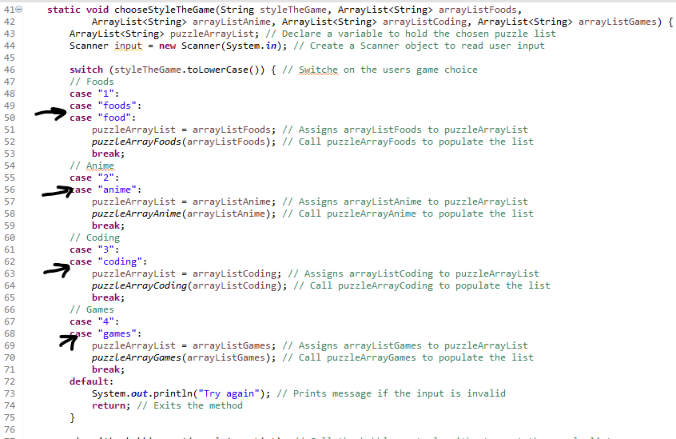

I faced a problem with not converting from an array char to String. When I worked on changing the letters of words, I did return char and not string, which led to the code not working. I sent the debugger's indication that there was an error in my code, which was that I did not put string.

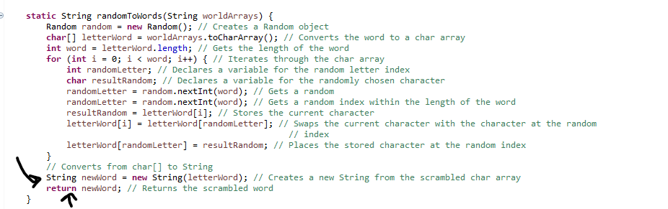

Part 5:

1. What coding standards do you follow when writing code?

I follow the Java standards while writing the code and they help me improve the code writing.

Coding standards:
They are standards that are generally accepted and followed by programmers in order to ensure consistency in the code and so that it is easy for programmers to understand and read, even if it was written by other programmers.

Examples of this include:
  - Adding comments, I did this on every line of my code so that it would be understood and explain what each line of code does. Examples include single and multiply lines.

  - Indentation: To find out the code, follow any score in the code.

  - The opening and close bracec location

  - One stantment per line, as it follows that each line contains one stantment in each line.

  - Naming consentios I followed this on all the code so that the names of the class, package, function, and variables are suitable for the intended purpose they represent and explain what it does.

  - Camel case, where I made sure that the variables of the first letter of the name are lowercase and the method, but if the name consists of two words, the second part of the word with the first letter is uppercase.
2. Describe any specific naming conventions prescribed by the coding standard you follow. How do these conventions help improve code readability and maintainability.

  - Adding comments, I did this on every line of my code so that it would be understood and explain what each line of code does. Examples include single and multiply lines.
For example:
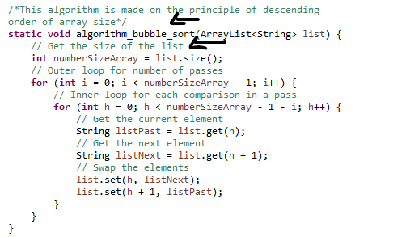
  - Indentation: To find out the code, follow any score in the code.
For example:
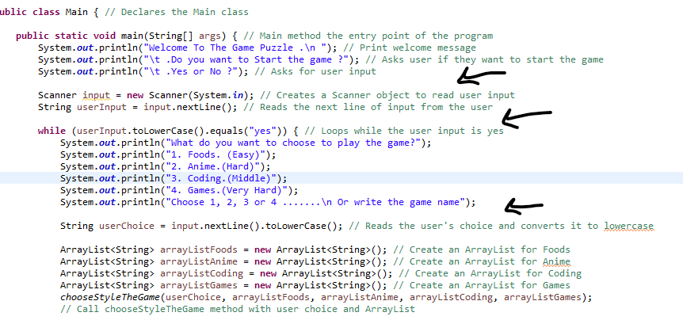

  - The opening and close bracec location
For example:
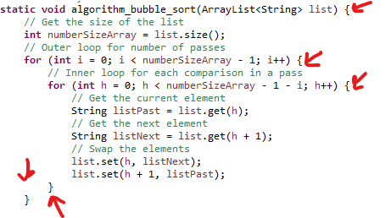
  - One stantment per line, as it follows that each line contains one stantment in each line.
For example:
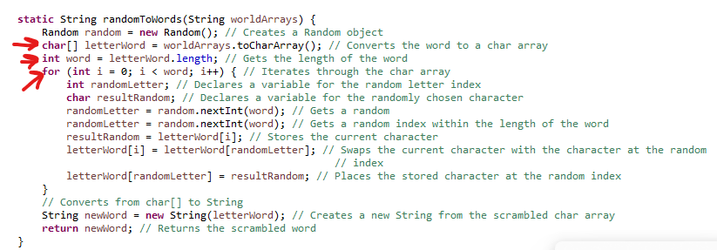
  - Naming consentios I followed this on all the code so that the names of the class, package, function, and variables are suitable for the intended purpose they represent and explain what it does.
For example:
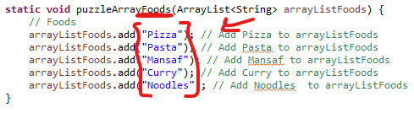

  - Camel case, where I made sure that the variables of the first letter of the name are lowercase and the method, but if the name consists of two words, the second part of the word with the first letter is uppercase.
For example:
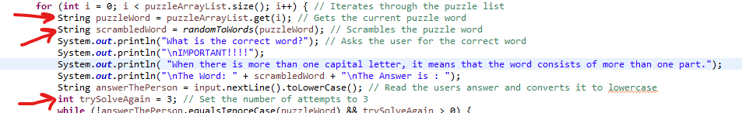

Conventions help improve code readability and maintainability. Adhering to code base naming conventions makes it easier for any developer to read and understand the code, regardless of who wrote it, if a problem occurs. Using descriptive names for classes, methods, and variables helps communicate the purpose of code. code elements, reducing the need for extensive comments. And quickly understanding the code if we want to modify the application.

3. Why do you believe having a coding standard is important for a development team? What benefits
does it offer in terms of collaboration, code quality, and project success.
3. Why do you believe having a coding standard is important for a development team? What benefits does it offer in terms of collaboration, code quality, and project success.
Yes, I think it is important to have programming standards in the development team, as this helps and contributes to understanding any code that is written by another member of the team. While a member of the team is assigned to bear a problem in a specific code, it is important that he follows within the programming standards so that he can quickly understand and analyze the code to solve the problems he faces. This makes the project successful when team members cooperate in working on the code within software standards, improving it, and developing it. It reduces the time spent reviewing code, and increases the overall productivity of team members. While no work has been done on standards, it leads to a lack of organization and understanding of the code for the team, and when a problem occurs, it will be very difficult to modify it.

Reference:
- Bubble sort - data structure and algorithm tutorials (2024) GeeksforGeeks. Available at: https://www.geeksforgeeks.org/bubble-sort/ (Accessed: 02 June 2024).
- Introduction of compiler design (2023) GeeksforGeeks. Available at: https://www.geeksforgeeks.org/introduction-of-compiler-design/ (Accessed: 02 June 2024).
- . (No date) Ada Computer Science. Available at: https://adacomputerscience.org/concepts/procprog_paradigm?examBoard=all&stage=all (Accessed: 03 June 2024).
- Bhatia, S. (no date) What is procedural programming? [definition] - key features, Hackr.io. Available at: https://hackr.io/blog/procedural-programming (Accessed: 03 June 2024).
- GeeksforGeeks (2024) Understanding classes and objects in Java, GeeksforGeeks. Available at: https://www.geeksforgeeks.org/understanding-classes-and-objects-in-java/ (Accessed: 04 June 2024).
- Attributes and methods in object-oriented programming (no date) DummySkiller. Available at: https://www.dummyskiller.in/attributes-and-methods-in-object-oriented-programming (Accessed: 05 June 2024).
- Rai, A. (2024) 7 steps to improve code quality, Stackify. Available at: https://stackify.com/7-steps-to-improve-code-quality/ (Accessed: 07 June 2024).
- Testing code: Types and benefits for software development (no date) RSS. Available at: https://bluelight.co/blog/code-testing (Accessed: 07 June 2024).
- The debugging process and techniques for web applications: Part 1/2 (no date) Highlight. Available at: https://www.highlight.io/blog/the-debugging-process-and-techniques-for-web-applications-part-1-2 (Accessed: 09 June 2024).
- The 10 major Java security vulnerability types (2023) MergeBase. Available at: https://mergebase.com/blog/java-security/ (Accessed: 09 June 2024).

